**Department of Electronics and Communication Central University of Rajasthan, Ajmer**



Signal and System Lab

Subject ...................................................................................................

ECE 214

Subject Code ...................................................................................................

5

111

Experiment No. .......................................................................................

Date:- - -2024

Roll no:- 2022BTECE012

Name:- Ojasvee Satija

**Title: -** Write MATLAB code to perform Arithmetic operation Addition, Subtraction, Multiplication and Division on signals

**Apparatus required:** - Downloaded MATLAB or OCTAVE software in device.

**Introduction:**- Arithmetic operations Addition, Subtraction, Multiplication and Division on signals are used to modulate two signals as one signal.

**Code:-**

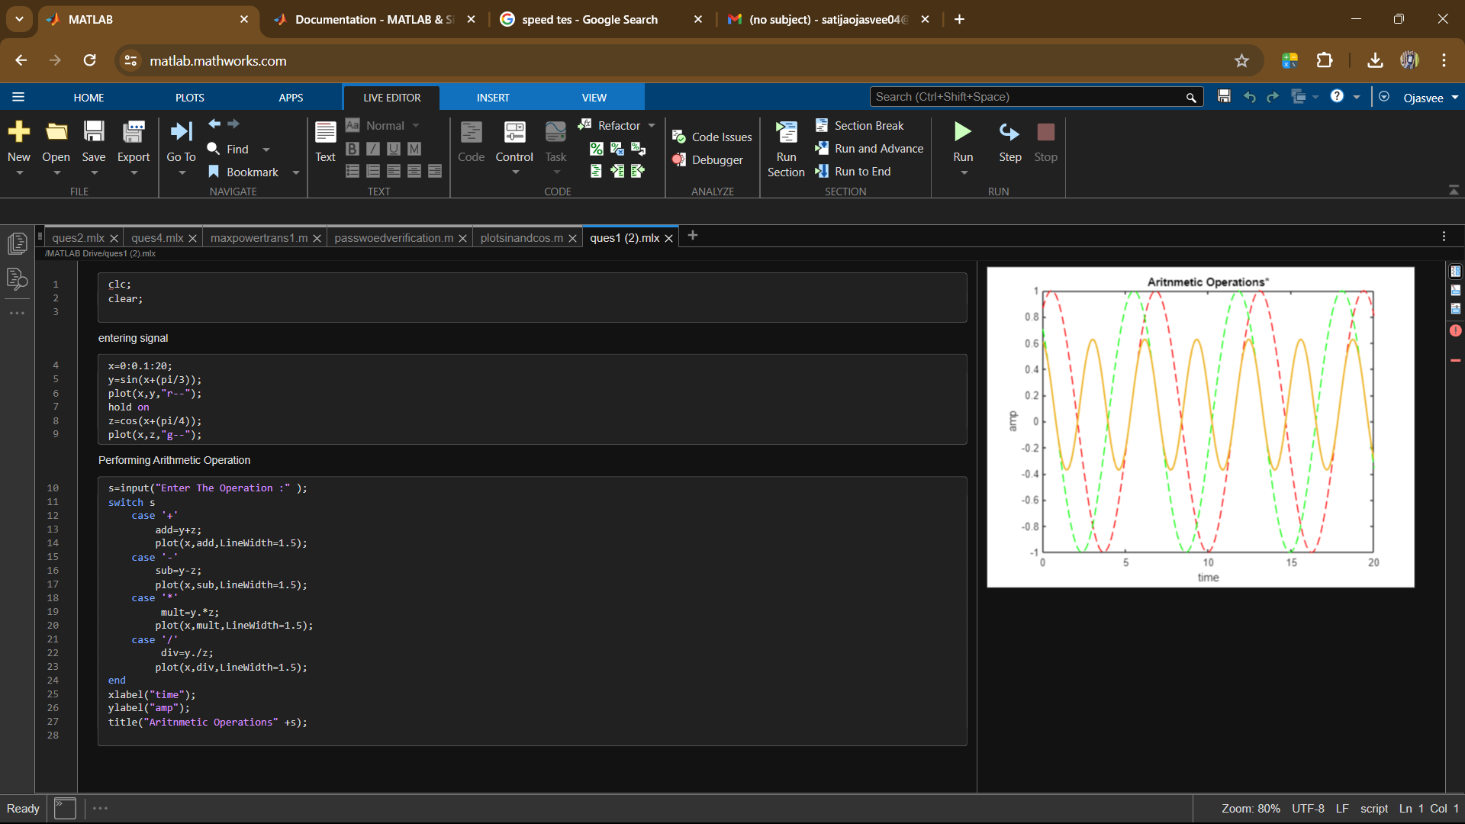

**Input and output:-**

* **A screenshot of a computer

  Description automatically generated**
* 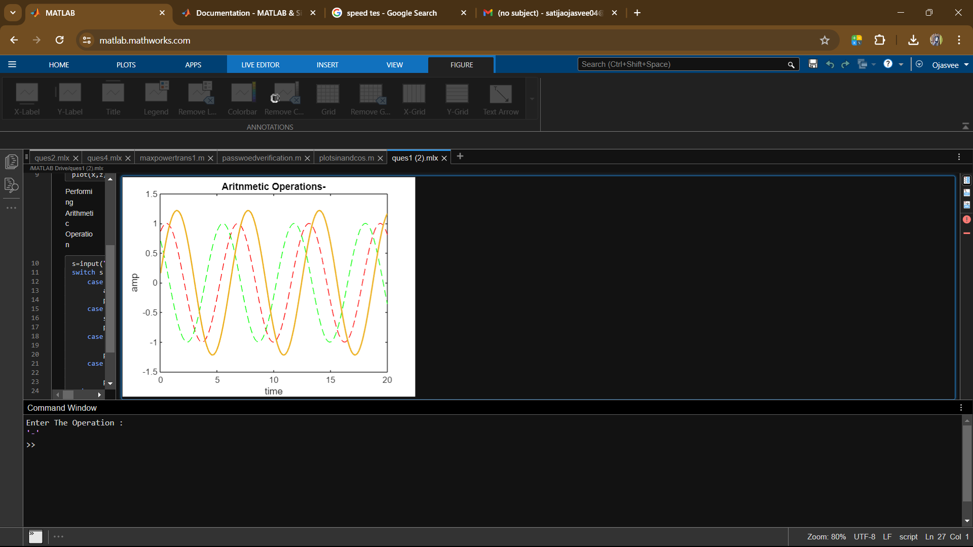
* 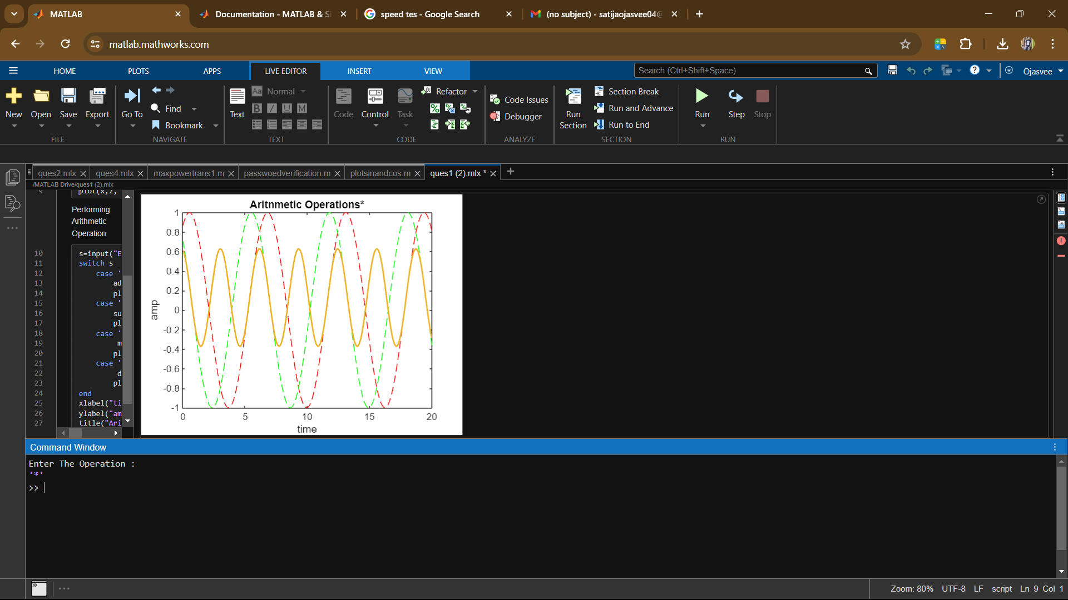
* 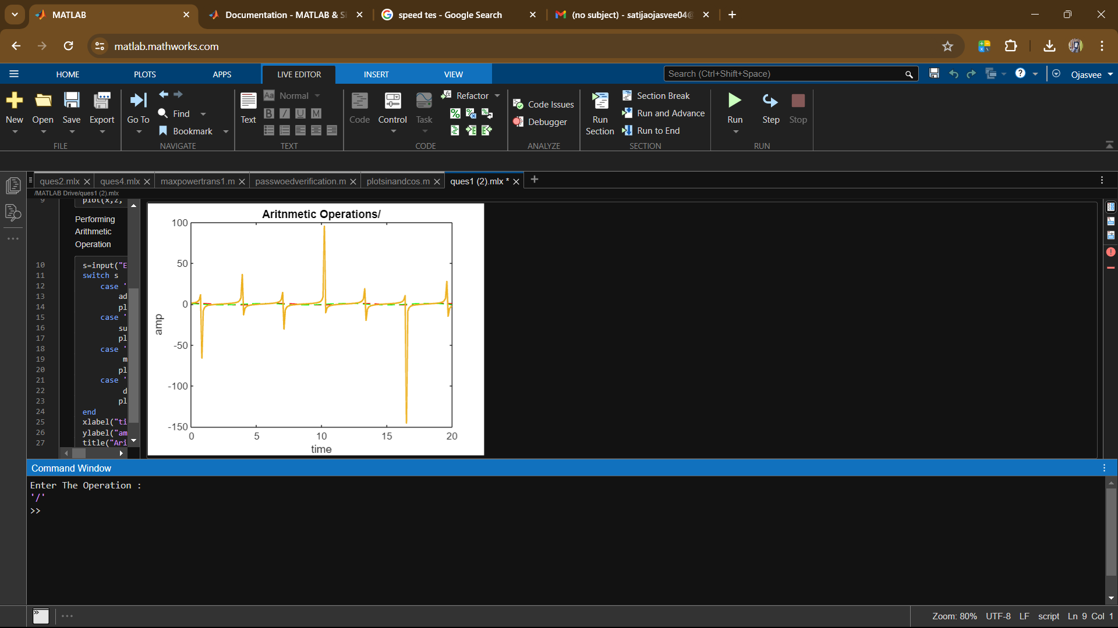

**Result:-** Performed the Arithmetic operation Addition, Subtraction, Multiplication and Division on signals